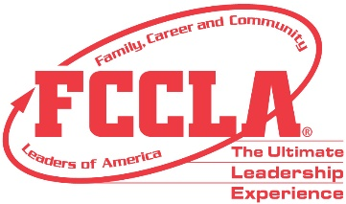
PROCLAMATION
FCCLA WEEK
[FCCLA Week Dates]

WHEREAS,
Family, Career and Community Leaders of America (FCCLA) is a national nonprofit, intracurricular Career and Technical Student Organization that supports Family and Consumer Sciences education by preparing students for leadership, careers, and civic engagement through integrated classroom and applied learning experiences; and
WHEREAS,
The organization extends classroom learning through chapter service projects that develop leadership and employability skills and helps young men and women learn how to plan, make decisions, carry out program evaluations, and take action through working with other youth and adults within their school, community, and state; and
WHEREAS,
FCCLA offers members an opportunity to work together for everyday purposes for the improvement of themselves, as well as their families, careers, and communities, and
WHEREAS,
The week of [FCCLA Week Dates], has been designated national FCCLA Week.
NOW, THEREFORE,
I, [Insert Name of Elected Official], hereby proclaim the week beginning [Insert Date], as national FCCLA Week in [Insert Community/State] and urge all citizens to acquaint themselves with the activities and values of Family, Career and Community Leaders of America, to show interest in, and provide support and encouragement to the students who are working to achieve knowledge and experience that will help prepare them for future responsibilities as active and concerned adult members of society.

___________________________ ___________________ _________________
Signature Title Date

