[Your Organization's Letterhead or Your Personal Information]
[Date]
Subject: Strong Endorsement for Establishing a Family and Consumer Sciences (FCS) Career Cluster
Dear [Recipient’s Name],
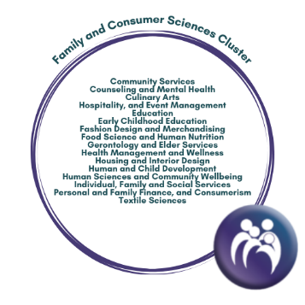
I write to you today as an advocate for education and as a dedicated [Your Role or Occupation] who wholeheartedly endorses the establishment of a Family and Consumer Sciences (FCS) Career Cluster within the framework provided by Advance CTE.
The FCS curriculum encompasses a wide array of crucial disciplines, including but not limited to (use list of FCS courses listed in the bubble graphic provided) [Relevant Field], [Relevant Field], and [Relevant Field]. These areas have never been more relevant than they are today. The world is changing rapidly, and with that, there is an escalating need for professionals well-versed in FCS-related fields. In my hometown of town/city, I have witnessed firsthand the incredible demand for skilled individuals in areas like (insert field(s)). These professionals are instrumental in addressing some of the most pressing challenges in our communities.
Establishing an FCS Career Cluster will serve these essential markets and many more that exist within the FCS Cluster. Recognition of the careers in FCS that provide workforce skills for all communities will help fill the gap in these areas and propel the recognition of these careers that are important for community and social success.
By establishing an FCS Cluster, we not only acknowledge the expanding market for these professions but also emphasize the significant role they play in promoting the welfare and success of communities. Recognition of FCS as its own career cluster is essential to breaking down gender stereotypes and welcoming individuals of all genders into roles such as (insert example here).
In conclusion, the case for an FCS Career Cluster is compelling. FCS meets the increasing job market demands, provides vital skill development, and offers diverse career paths, which necessitates its own distinct Career Cluster. The establishment of this cluster is paramount to providing equitable recognition to FCS professionals, satisfying the requirements of educational institutions, and responding to the needs of industry that are central to the well-being of our society
I urge you to consider this endorsement and to play a pivotal role in paving the way for the new FCS Career Cluster. Our students, our communities, and our society as a whole will benefit from this important step forward.
Sincerely,
[Your Signature]
[Your Name]
[Your Title]
[Your Organization or Affiliation]

