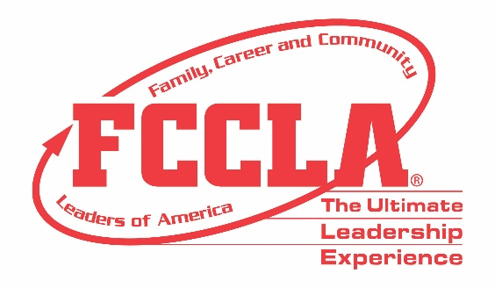

**FOR IMMEDIATE RELEASE** **Contact:** *Marissa Kunerth*

**July 1, 2020** *Communications & Public Relations Manager*

**Phone:** *703.716.1308*

**Email:** *mkunerth@fcclainc.org*

***(FCCLA Chapter/School Name)* Conducts Community Traffic Safety Project through**

**FCCLA’s FACTS National Program**

**Reston, VA** – *(FCCLA Chapter)* from *(City, State)* was one of 136 Family, Career and Community Leaders of America (FCCLA) chapters from 19 states to conduct a Families Acting for Community Traffic Safety (FACTS) National Program traffic safety project in their community during the 2019-2020 academic year. All projects involved youth working together to educate adults and youth about traffic safety and support enforcement of local rules and regulations regarding community traffic safety.

In leading traffic safety projects, chapters utilized FCCLA’s FACTS Community Needs Assessment tool to survey their school and identify the traffic safety topic that were most important to their community. FCCLA chapters’ community traffic safety projects covered topics including speeding, seat belt safety, school bus safety, pedestrian safety, new driver education, infrastructure safety, inclement weather, impaired driving, drowsy driving, distracted driving, child passenger safety, bicycle safety, and aggressive driving.

*(Insert Chapter Project Description)*

More than 4,500 members participated in the program and reached a combined total of 280,561 community members through project efforts. Chapters also reported reaching approximately 424,484 community members through public relations efforts with local media sources.

Additionally, State Highway Safety Office representatives reviewed FACTS applications in their state and selected top project for a $500 award, sponsored by Ford Driving Skills for Life (Ford DSFL) and the Governors Highway Safety Association (GHSA). 15 chapters highlighted their participation in the Ford Driving Skills for Life Academy or live event in their projects.

*(Insert Quote from Chapter About Project Takeaways)*

From among these state winners and other top FACTS projects, FCCLA’s National Executive Council selected the three National Program Award Winners. This year’s FACTS National Program Award winners are “Just Drive” by Black River High School, Ohio, “Arrive Alive” by Granville Middle School, Ohio, and “Safety Starts with You!” by Howells-Dodge High School FCCLA, Nebraska. All national winners will be recognized at FCCLA’s Virtual National Leadership Conference, July 7-9, 2020, in partnership with Ford DSFL and GHSA.

***About FCCLA***

Family, Career and Community Leaders of America ([FCCLA](http://www.fcclainc.org/)) is a dynamic and effective national student organization that helps young men and women become leaders and address important personal, family, work, and societal issues through Family and Consumer Sciences education. FCCLA has more than 182,000 members and 5,253 chapters from 48 state associations, Puerto Rico, and the Virgin Islands.

###