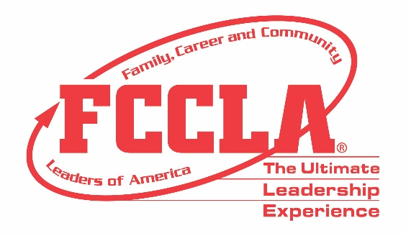

FOR IMMEDIATE RELEASE Contact: Marissa Kunerth
Communications & Public Relations Manager
Phone: 703-716-1308
Email: mkunerth@fcclainc.org

(Insert Master Adviser Recipient’s Name), (Insert Name of School/Chapter Here)’s Family and Consumer Sciences Teacher, is Recognized as Master Adviser at National Leadership Conference

Reston, VA – Family, Career and Community Leaders of America (FCCLA) will host it's first-ever Hybrid National Leadership Conference June 27-July 2, 2021, in Nashville, TN, and on a virtual platform. (Insert Adviser's Name) from (Insert the Adviser's School), will be recognized with the Master Adviser Award amongst 26 other fellow 2021 Master Adviser recipients nationwide.

FCCLA's Master Adviser Award acknowledges advisers who have successfully advised an affiliated chapter for a minimum of three years. Master Advisers continuously promote FCCLA and Family and Consumer Sciences (FCS) education, operate an integrated chapter with a balanced program of work, facilitate youth-centered activities, and continue to integrate new ideas and FCCLA happenings.

(Insert paragraph about Adviser’s FCCLA chapter and FCS professional accomplishments)

"It is difficult to put into words how appreciative the Board of Directors, National Staff, and FCCLA members are to have Master Advisers lead FCCLA chapters across the country," said Sandy Spavone, Executive Director of FCCLA. "With this honor, these advisers deserve endless recognition for their accomplishments and continued efforts to grow FCCLA and FCS education."

Thanks to the guidance and groundwork of FCCLA Master Advisers, members can excel in Competitive Events, serve in leadership roles, and gain real-world expertise through FCS education. Through their work, members positively impact families, careers, and communities across the nation. FCCLA Master Advisers are essential in motivating and mentoring members to reach their highest potential in the classroom and thrive in the 21st century workforce.

About FCCLA
Family, Career and Community Leaders of America (FCCLA) is a dynamic and effective national student organization that helps young men and women become leaders and address important personal, family, work, and societal issues through Family and Consumer Sciences education. FCCLA reaches more than 180,000 members and over 5,000 Family and Consumer Sciences educators in the United States and territories.

###

