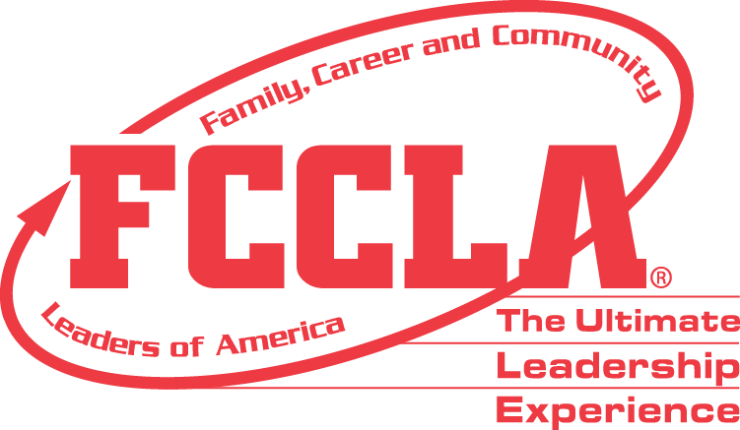
National Consultant Team
APPLICATION

Thank you for taking the time to complete the application for the FCCLA National Consultant Team! The National Consultant Team (NCT) is a group of advisers who lead the Adviser Academy, Develop and lead the Chapter Adviser Summit, develop trainings, lead workshops, develop resources, and generally serve as an extension of national staff at the National Leadership Conference.

SECTION 1: Basic Information
Please complete the following information. If any information does not apply to you, please fill in the field with “N/A.”

Personal

First Name: ______________________________ Last Name: _________________________________
School Address: _______________________________________________________________________
Home Address: ________________________________________________________________________
Cell Phone Number: _____________________ Alt. Phone Number: __________________________
Email Address: ________________________________________________________________________
Years of Experience as an FCCLA Adviser:___________________________________________________
Chapter ID Number: ____________________________________________________________________

FCCLA Involvement
- FCCLA Background (Identify national programs and activity work, attendance/participation in state association, Chapter Adviser Summit, Adviser Academy, and National Leadership Conferences):

- Family and Consumer Sciences Background:

- Presentation and Program Development Experience:

- Professional Activities and Memberships:

- School/Community Activities (Describe any community and other activities in which you are or have been involved that would support your application):

SECTION 2: Short-Answer Questions
In this section, you will answer questions related to your past leadership experience, as well as what you will bring to the National Consultant Team. Please answer each question in complete sentences, and limit your responses to the space provided for each question.

- Complete a short statement concerning the following: “What I can offer advisers through my participation as an FCCLA National Consultant Team Member.”

- What is your strongest quality as an FCCLA Adviser? Describe an instance where that skill was particularly useful.

- What is your FCCLA specialty and how can you use it to contribute to the team?

SECTION 3: Show Your Skills

In this section, you will submit materials to demonstrate your ability to present and plan a workshop. Both of these skills will be an integral part of your career as a member of the National Consultant Team if you are chosen.

Video
You will submit a video of yourself that demonstrates your ability to present an original lesson plan. The video should be no more than fifteen minutes long, and should reflect all or a portion of your planned lesson. The presentation style should be directed to the intended audience, but you need not present the workshop for an actual audience in your video if one is not available.

Evaluation Criteria:
You will be evaluated on the following criteria for the video portion:

- Staying within the 15-minute time constraint
- The originality and creativity of how you present your leadership lesson
- How well your chosen theme is conveyed in the workshop
- Ability to express self and ideas clearly

The video of your workshop must be uploaded to YouTube by May 23, 2024. Please provide a link to the video here:

Please email your application and supporting materials to: mhedrick@fcclainc.org

Applications must be submitted by May 23, 2024

