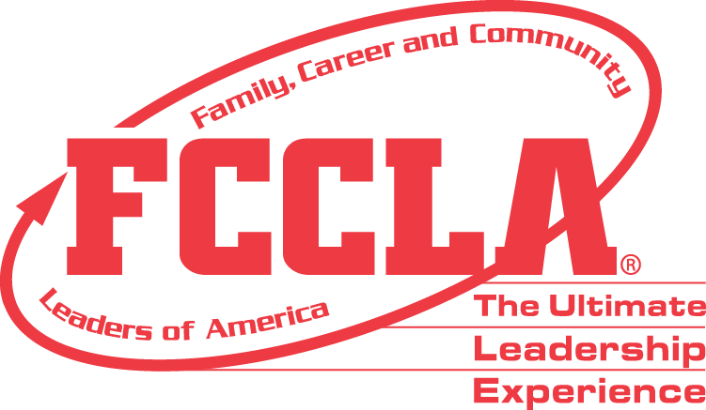
NATIONAL CONSULTANT TEAM
APPLICATION INFORMATION & INSTRUCTIONS
Family, Career and Community Leaders of America is seeking to enlist talented FCCLA® advisers from a variety of diverse backgrounds to join the National Consultant Team (NCT). NCT members lead the Adviser Academy, develop and host professional development trainings, lead workshops, develop resources, and generally serve as an extension of national staff at the National Leadership Conference, in addition to the roles and responsibilities listed below.
Composition
The National Consultant Team (NCT) consists of successful FCCLA® advisers with expertise in chapter management, national programs and activities, intra-curricular work, membership development, public policy, and visibility.

NCT members are expected to have a degree in or be certified to teach Family and Consumer Sciences courses, currently teach a class in middle school or high school Family and Consumer Sciences or a related supervisory role and serve or have served as a local chapter adviser.

Members of the National Consultant Team will serve for two consecutive years. They may reapply in their second year if they wish to be considered for additional terms. If an NCT member has retired from teaching at any point during their two-year term as a National Consultant, they are requested to resign the position within one year after the day of retirement.

Roles and Responsibilities
Members of the National Consultant Team will have various responsibilities that include working with national staff before, during, and after conferences and throughout the year. They will have full schedules during conferences and should not plan to chaperone students while serving as an NCT member. General responsibilities may include, but are not limited to:
- Develop and implement professional development training for FCCLA Advisers
- Conduct evaluation and provide feedback and attendance to staff following all training
- Write articles and activities used for the FCCLA website and publications
- Present workshops at meetings that may include state conferences
- Assist at national meetings as assigned (NLC, Capitol Leadership, CAS,etc.)
- Serve as positive and professional representatives of the national organization

Compensation
National Consultant Team members receive compensation for their time and materials. Below is an outline of most items for which consultants can expect compensation. Additional items may be written into individual contracts or decided upon and assigned as needed.
- National Leadership Conference (July): $300 honorarium + expenses paid
- Adviser Academy (November – March): $300 (includes preparation and actual time for the presentation).
- Capitol Leadership (September)/October): $250 honorarium + expenses paid
- State Meetings/Workshops: $100 honorarium + expenses paid, must be arranged and paid for by host state through FCCLA national headquarters.
- Additional National Meetings (as needed): $250 + expenses paid
- $50 stipend for Adviser Webinars

Application Submission Information
Application Checklist:
- Basic Information
- Short Answer Questions
- Video
- Three Letters of Recommendation, one each from:
- Colleague (can be an educator in FCS or other subject area)
- School or District Administrator
- FCCLA State Adviser

Please email your application and supporting materials to: mhedrick@fcclainc.org

Deadline: May 23,2024

