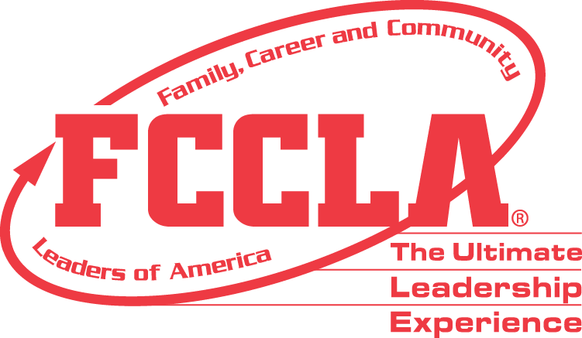

FOR IMMEDIATE RELEASE Contact: Marissa Kunerth
Communications & Public Relations Manager
Phone: 703-716-1308
Email: mkunerth@fcclainc.org

(Insert Student’s Name) from (Insert High School/Chapter) Elected to Serve on FCCLA’s
2021-2022 National Executive Council
(Insert Headshot)

Reston, VA – (Insert Student’s Name) from (Insert Student’s School/Chapter) was one of ten national officers elected to serve on the Family, Career and Community Leaders of America’s (FCCLA) National Executive Council (NEC) at FCCLA’s Hybrid National Leadership Conference. (Student’s Name) is son/daughter of (Insert Parent’s Names) and will be serving as FCCLA’s (Insert Office Position) throughout the 2021-2022 school year.

FCCLA hosted its first-ever Hybrid National Leadership Conference, June 27-July 2, 2021, in Nashville, TN, with more than 2,5000 registered attendees participating either in-person or virtually. 25 National Officer Candidates from across the country took part in the National Executive Council election process and underwent intense interviews, an online FCCLA knowledge test, and presented a three-minute prepared speech in front of all conference attendees.

FCCLA’s National Executive Council (NEC) works as a team throughout the year and is made up of ten officer positions. The NEC primary function is program development, program implementation, and public relations. The NEC has responsibilities that range from planning for FCCLA’s national conferences to promoting FCCLA’s National Programs, Competitive Events, Career Pathways, and other leadership opportunities. The council will build off existing goals to prepare a program of work and as well as develop future goals for the organization.

(Insert Quote from Newly Elected National Officer) said (Insert Officer’s Name), (Insert Student’s Position) of FCCLA 2021-2022 National Executive Council.
Being elected to serve on the National Executive Council is the highest leadership honor a FCCLA member can achieve. National Officers serve as role models alongside their National Executive Council Adviser and set a positive example for FCCLA’s entire membership. Inspired by this year’s theme, officers are challenged to “Make it Count” to as they lead FCCLA’s more than 180,000 members and over 5,000 Family and Consumer Sciences educators toward new horizons.
About FCCLA
Family, Career and Community Leaders of America (FCCLA) is a dynamic and effective national student organization that helps young men and women become leaders and address important personal, family, work, and societal issues through Family and Consumer Sciences education. FCCLA reaches more than 180,000 members and over 5,000 Family and Consumer Sciences educators in the United States and territories.

###

