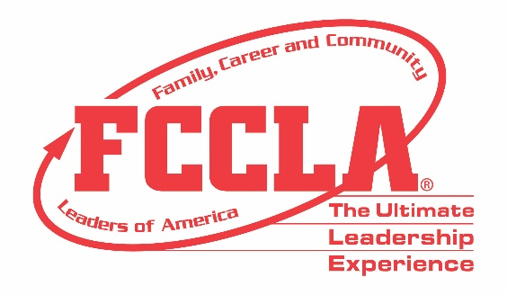

FOR IMMEDIATE RELEASE Contact: Marissa Kunerth
Communications & Public Relations Manager
Phone: 703-716-1308
Email: mkunerth@fcclainc.org

(Insert Adviser’s Name) from (Insert High School/Chapter) To Serve as National Executive Council Adviser
(Insert Headshot)

Reston, VA – (Insert Adviser’s Name) from (Insert Adviser’s School/Chapter) will serve as one of ten National Executive Council Advisers (NECA) representing Family, Career and Community Leaders of America (FCCLA) throughout the 2021-2022 school year. (Insert Adviser’s Name) will be supporting (Insert Student’s Name) who was elected to serve as the (Insert Officer’s Position) on the National Executive Council at FCCLA’s first-ever Hybrid National Leadership Conference, June 27-July 2, 2021, in Nashville, TN.

The ten National Executive Council Advisers will support their National Officers in guiding FCCLA members, preparing for conference, meetings, and events, assisting National Staff, and representing the organization in various capacities. These advisers provide valuable Family and Consumer Sciences (FCS) knowledge and intuition as well as FCCLA experience used to help advance FCCLA nationally.

Throughout the year, NECA will support their National Officer through program planning sessions where they will receive professional development training, discuss responsibilities, participate in team building exercises, and assist his/her National Officer. In addition, the NECA will help plan the focus and content of adult sessions at various national conferences and events to be held throughout the 2021-2022 academic year.

(Insert Quote from Adviser) said (Insert Adviser’s Name), about this year’s National Leadership Conference and her excitement in serving as (Insert Student’s Name) NECA.

FCCLA is looking forward to another successful year filled with innovative and enthusiastic leadership from the newly elected National Executive Council and National Executive Council Advisers and cannot wait to see how these advisers make the Ultimate Leadership Experience count in serving more than 180,000 members and over 5,000 FCS educators across the nation.

About FCCLA
About FCCLA
Family, Career and Community Leaders of America (FCCLA) is a dynamic and effective national student organization that helps young men and women become leaders and address important personal, family, work, and societal issues through Family and Consumer Sciences education. FCCLA reaches more than 180,000 members and over 5,000 Family and Consumer Sciences educators in the United States and territories.

###

