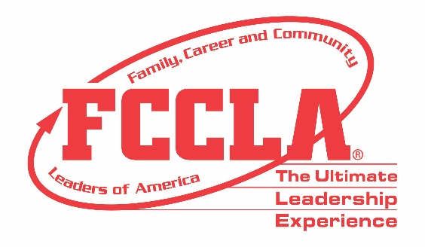

FOR IMMEDIATE RELEASE Contact: Marissa Kunerth
July 1, 2020 Communications & Public Relations Manager
Phone: 703.716.1308
Email: mkunerth@fcclainc.org

(FCCLA Chapter/School Name) Receives $1,000 Grant to Conduct a Traffic Safety Project

Reston, VA – (FCCLA Chapter Name) was one of 50 Family, Career and Community Leaders of America (FCCLA) chapters from Ohio awarded a $1,000 traffic safety grant in April 2020. In partnership with the Ohio Department of Public Safety and supported by Ford Driving Skills for Life and the Governors Highway Safety Association, grantees used the funds to conduct a traffic safety project in their community.

In leading traffic safety projects throughout Ohio, grantees utilized FCCLA’s Families Acting for Community Traffic Safety (FACTS) Community Needs Assessment tool to survey their school and identify the traffic safety topic that were most important to their community. Grantees’ community traffic safety project covered topics including bicycle safety, impaired driving, distracted driving, pedestrian safety, aggressive driving, seat belt safety, speeding, child passenger safety, school bus safety, impaired driving, drowsy driving, and infrastructure safety.

(Insert Chapter Project Description)

Nearly 850 members participated in this program and reached a combined total of 196,628 individuals through chapter project efforts. In addition, Ohio FCCLA chapters also reported reaching approximately 332,280 individuals through public relations efforts with local media sources.

Of the 50 Ohio FCCLA chapters awarded a $1,000 grant, the Ohio Department of Public Safety selected four chapters to receive an additional $2,500 for their outstanding achievement and work to save lives through addressing personal, vehicle, and road safety. The four $2,500 winners selected are: Van Wert High School—Vantage Career Center, Black River High School, Anthony Wayne Jr. High School—Penta Career Center, and Fairfield Union High School.

(Insert Quote from Chapter About Project Takeaways)

About FCCLA
Family, Career and Community Leaders of America (FCCLA) is a dynamic and effective national student organization that helps young men and women become leaders and address important personal, family, work, and societal issues through Family and Consumer Sciences education. FCCLA has more than 182,000 members and 5,253 chapters from 48 state associations, Puerto Rico, and the Virgin Islands.

###

