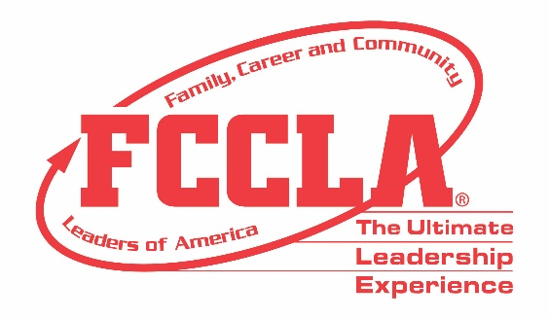

FOR IMMEDIATE RELEASE Contact: Marissa Kunerth
Communications & Public Relations Manager
Phone: 703-716-1308
Email: mkunerth@fcclainc.org

(Insert Student’s Name) Leads FCCLA’s First-Ever Hybrid National Leadership Conference as a National Officer
(Insert Photo of NEC)

Reston, VA – (Insert Student’s Name) from (Insert Student’s High School/Chapter) served this past year as (Insert FCCLA Position) on Family, Career and Community Leaders of America’s (FCCLA) National Executive Council (NEC). Ten youth leaders are elected annually by their peers at FCCLA’s National Leadership Conference to serve for a one-year term as the representative body of FCCLA.

Serving on the National Executive Council is one of FCCLA’s most prestige honors a member can achieve. FCCLA is the only student led Career and Technical Student Organization with family as its central focus. The National Executive Council helps center that focus through their chapters and affiliations by completing their primary functions of program development, program implementation, and public relations. This past year, the NEC was involved in teamwork, leadership and employability skill-building, as well as conference development to further the reach and involvement of National FCCLA.

As part of the 2020-2021 National Executive Council, (Insert Student’s Name) was tasked with developing and leading State Officers, planning and hosting workshops for various meetings, promoting Family and Consumer Sciences Education, as well as conducting all general sessions at the Hybrid National Leadership Conference, June 27-July 2, 2021 for more than 2,500 attendees—in addition to other meetings and various events throughout the year. The NEC’s work is very much appreciated, and helps advance FCCLA on the local, state, and national level.

(Insert Highlights on the local, state, and national level of specific National Officer)

FCCLA was the only Career and Technical Student Organization to host an in-person National Leadership Conference this school year. (Insert Quote from NEC), said (Insert Student’s Name) in reflecting on FCCLA’s 2021 Hybrid National Leadership Conference and the skills and experiences gained throughout her/his time serving as a National Officer.

About FCCLA
Family, Career and Community Leaders of America (FCCLA) is a dynamic and effective national student organization that helps young men and women become leaders and address important personal, family, work, and societal issues through Family and Consumer Sciences education. FCCLA reaches more than 180,000 members and over 5,000 Family and Consumer Sciences educators in the United States and territories.

###

