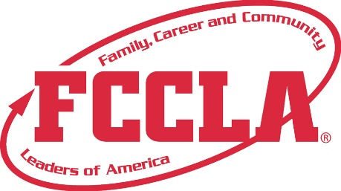

FOR IMMEDIATE RELEASE Contact: Your Name and Title
Phone: Your Phone
Email: Your Email

(Insert Chapter’s Name) from (Insert School’s Name) Attended the FCCLA National Leadership Conference in San Diego, CA June 29-July 3
San Diego, CA, July 2022 – (Insert Chapter’s Name) joined more than 7,000 Family, Career and Community Leaders of America (FCCLA) student members, advisers, and guests at the San Diego Convention Center, June 29-July 3 to participate in the annual National Leadership Conference (NLC).
The conference provided (chapter name) members opportunities for listening to inspiring speakers, attending youth workshops, competing on the national level, and networking with other youth leaders. The theme of this year’s conference was “Make It Count,” which inspired attendees to share how they make it count while exploring career opportunities, developing leadership skills, and growing personally while making a difference in their families and communities.
“We are thrilled to have an attendance of over 7,000 members, advisers, corporate partners, and guests who are committed to discovering the unlimited possibilities available through FCCLA. The relationships and skills developed during this conference have inspired students to make a difference in their own communities and to make every moment count,” said Sandy Spavone, Executive Director of Family, Career and Community Leaders of America.
(Insert Names of Students Who Attended NLC, List of Events Students Competed in, and Places Awarded)
Next year FCCLA will host its National Leadership Conference in Denver, CO, July 2-6, 2023. To learn more about how you can get involved as a student, sponsor, or supporter, contact (Insert Adviser’s Name) at (Insert School’s Name).
About FCCLA
Family, Career and Community Leaders of America (FCCLA) is a dynamic and effective national student organization with over 199,000 members nationwide, that helps students become leaders and address important personal, family, work, and societal issues through Family and Consumer Sciences education.
FCCLA: The Ultimate Leadership Experience is unique among youth organizations because its programs are planned and run by members, and it’s the only career and technical in-school student organization with a central focus on careers that support families. Participation in national FCCLA programs and chapter activities helps members become strong leaders in their families, careers, and communities.
###

