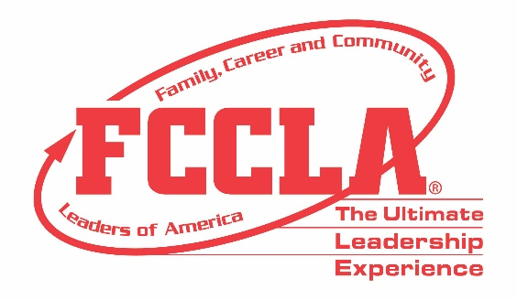

FOR IMMEDIATE RELEASE Contact: Marissa Kunerth
Communications & Public Relations Manager
Phone: 703-716-1308
Email: mkunerth@fcclainc.org

(Insert Teacher Name), Family and Consumer Sciences Teacher from (Insert School Name) is Honored with the Spirit of Advising Award at Hybrid National Leadership Conference

Reston, VA – (Insert FCS Teacher’s Name), a Family and Consumer Sciences (FCS) Teacher at (Insert School Name and Town/City), is one of 30 Family, Career and Community Leaders of America (FCCLA) Advisers nationwide who will be honored this year with a Spirit of Advising Award. (Insert Name) has been an FCCLA Adviser for more than (Insert years as an Adviser) years and will receive his/her award alongside the rest of the Spirit of Advising Award recipients during FCCLA’s first-ever Hybrid National Leadership Conference, June 27-July 2, 2021, in Nashville, TN.

FCCLA’s Spirit of Advising Award is an honor bestowed to only one adviser from each state association. The Spirit of Advising Award recognizes FCCLA advisers who consistently demonstrate excellence in modeling FCCLA character and integrity to ensure the success of their students within their classroom and career.

“FCCLA advisers are crucial to the organization’s success,” said Sandy Spavone, Executive Director of FCCLA. “Their constant dedication and support to Family and Consumer Sciences, youth leadership, and the organization exemplify the value of leadership throughout the community. Without these educators, FCCLA could not be the Ultimate Leadership Experience it is today.”

(Information about the Spirit of Advising Award recipient’s professional accomplishments)

It requires a unique set of skills and a tremendous commitment of time and energy to be a competent adviser. Exceptional advisers go above and beyond in serving their school, community, and state by connecting students to opportunities, using a wide variety of resources, and continuously working for the advancement of the organization. Thanks to advisers like (Insert Name), FCCLA is able to successfully prepare today’s students to be leaders of tomorrow’s society.

About FCCLA
Family, Career and Community Leaders of America (FCCLA) is a dynamic and effective national student organization that helps young men and women become leaders and address important personal, family, work, and societal issues through Family and Consumer Sciences education. FCCLA reaches more than 180,000 members and over 5,000 Family and Consumer Sciences educators in the United States and territories.

###

