Virtual Presentation Recording Tips

Lighting

Lighting can make or break the professionalism and appearance of an entire presentation. A general lighting guideline to follow when planning your virtual presentation is the Standard Three Point Lighting method. Utilizing this method can help to make a presentation look clean and professional. Use the steps below to help ensure that you will have the best possible lighting for your presentation.

With the camera directly in front of the presenter, there should be three light sources:

- Key Light
This light is located in front of presenter and off to one side opposing the fill light. This will act as the main light.

- Fill Light
This light is located in front of presenter and on the opposite side of the key light source. This is used to balance light on the opposite side of your face and eliminate the silhouette on half of your face due to the key light on opposite side.

- Back Light
This light is located behind the presenter, slightly off to one side. This is used in order to separate subject from background.

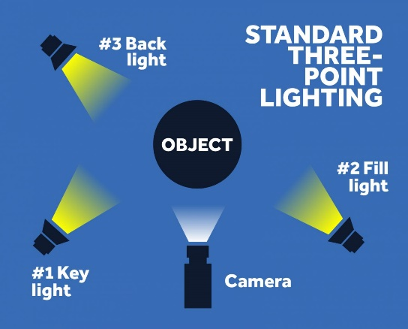

Click here if you would like to learn more about how utilizing Standard Three Point Lighting will benefit your overall video presentation.

TIP: If you do not have an abundance of standing lights in your home, position yourself in front of a window so that the natural light is on your face. However, try to avoid having windows behind you, as your face will be silhouetted.

Picture & Sound

Choose a clean background and quiet space free of distractions.
Set up your presentation in a location where no people, pets, or other sounds will pose as a distraction or interference with your presentation. Any minor movement or sound in the background can pose as a major distraction to your presentation.

Setting up the correct view of the subject.
Use your device’s view finder to ensure that the exposure, lighting, and frame are the best they can be.
Click here for tips on how to best frame the presenter.

First impressions are everything!
No matter where you are filming your presentation, an essential component of delivering a professional presentation is appearance!

**Student members are required to dress professionally when recording your presentation. FCCLA encourages you to “Rock the Red” in your official uniform, if possible, or your favorite FCCLA polo.

**Advisers, alumni, partners and other adults are asked to wear business casual or professional attire when recording your presentation.

TIP: You can check your appearance using your devices’ camera prior to recording your presentation. This can be found by using your device search bar. Using your camera can also help you to locate any distractions in your surroundings.

General Tips

Treat your virtual presentation like any other in-person presentation.
Memorizing your script before-hand, in conjunction with well-organized materials will work wonders for the overall quality of the presentation. Post-It notes are a great way to create quick reminders on your screen to see while recording.

Reminder - one the greatest benefit of recording a presentation is the ability to start over if necessary!

Be engaging, and don’t forget to smile!
Get out of your comfort zone by using more enthusiasm than may necessarily feel natural, as recordings do not always showcase natural energy to its fullest!

Timing is everything!
Be mindful of your presentations time limits

Additional Resources

- How to Record a Presentation
- Improve Your Presentation Skills

